Assignment 2 – Globalization

Gruppemedlemmer: Maksim Ohvrill, Anton Tran, Bjørn Eide, Carl Alfred Emanuel Nordqvist, Eirik Pedersen

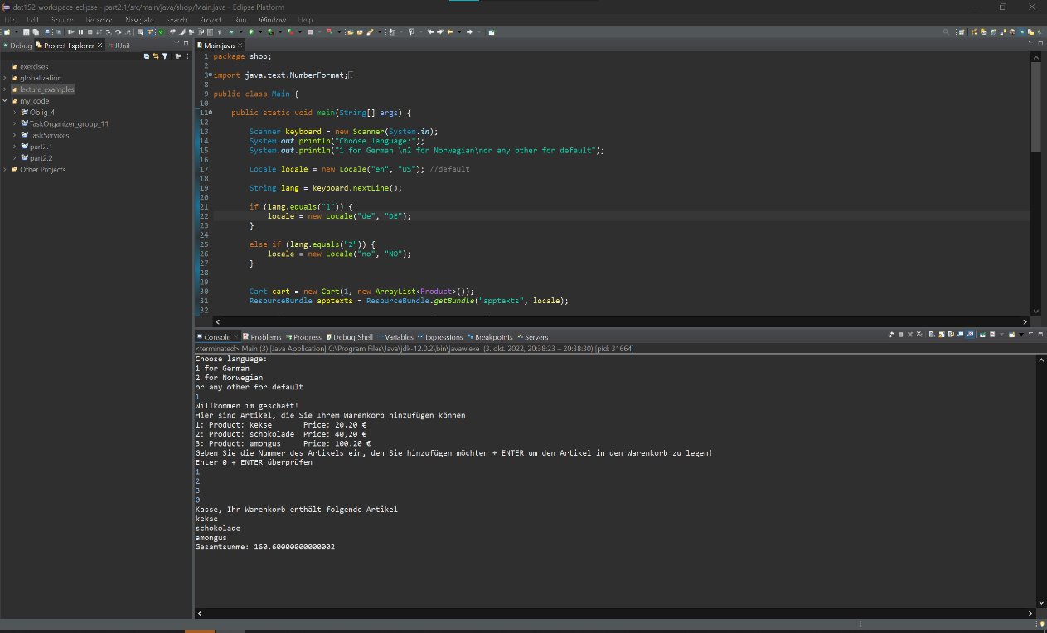

Figure 1 Global shop nonweb demo

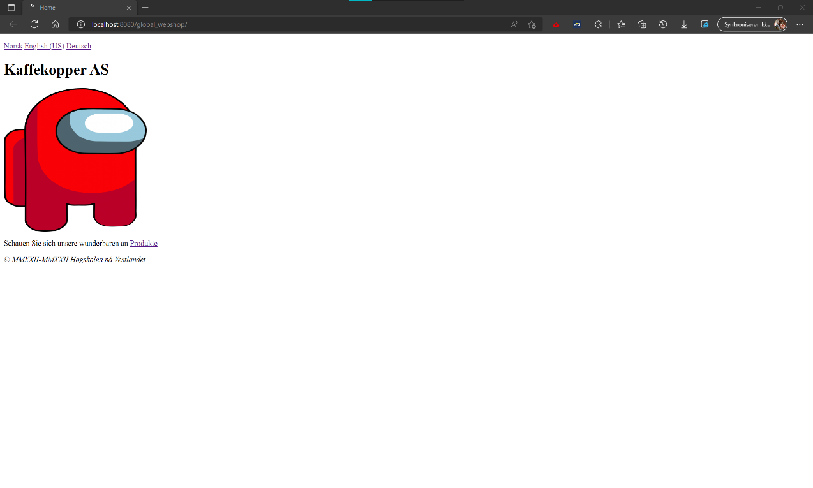

Figure 2 Global webshop demo home (ger)

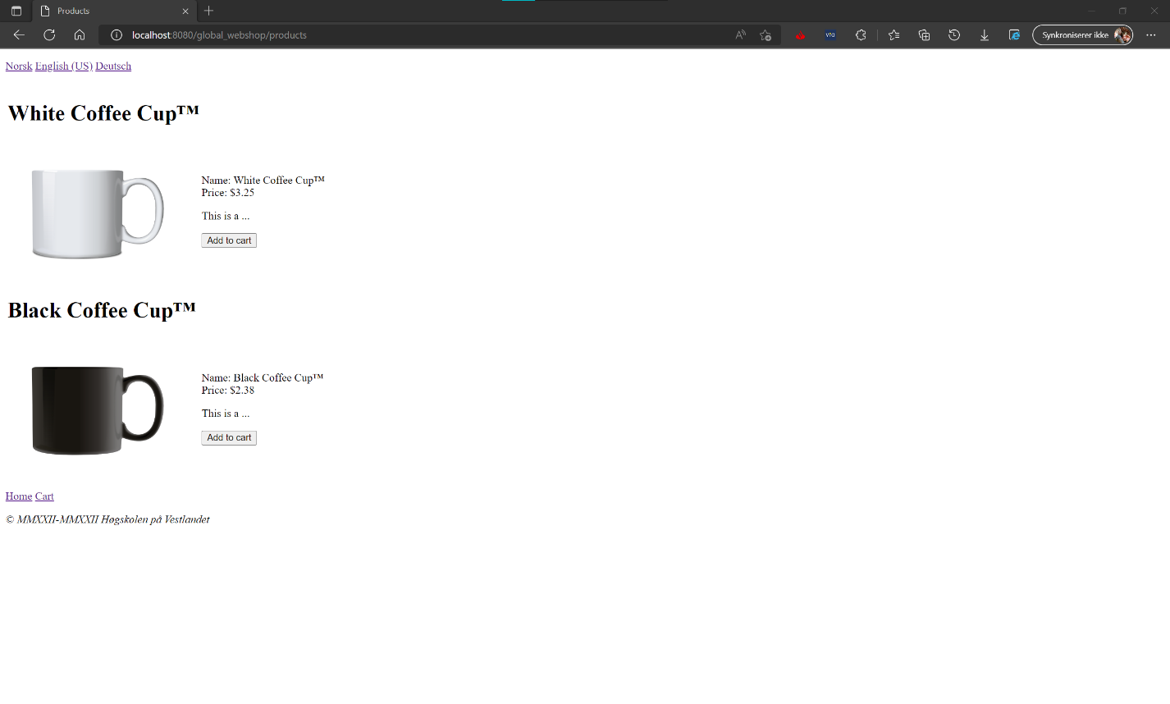

Figure 3 Global webshop demo products (eng)

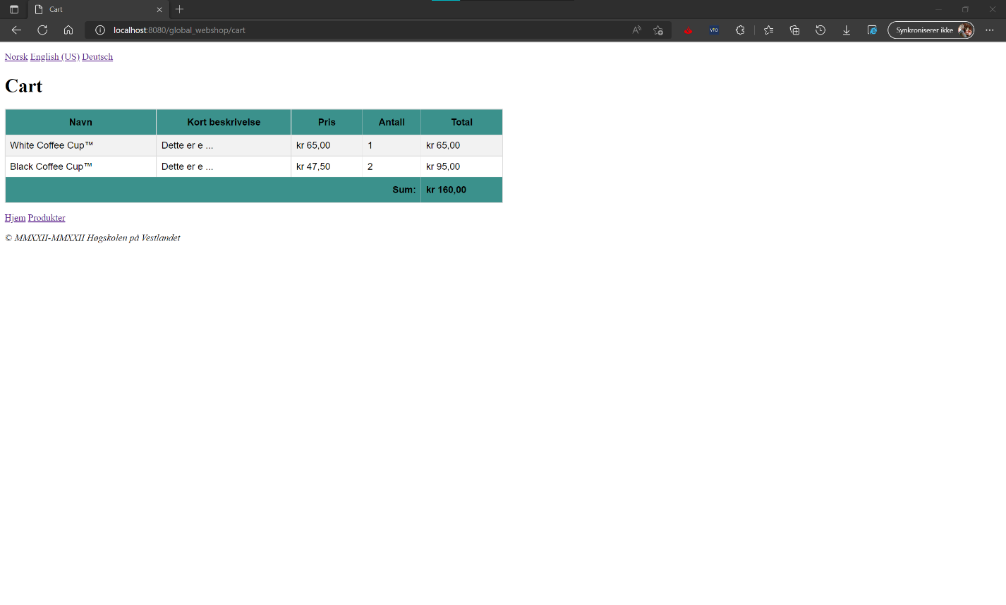

Figure 4 Global webshop demo cart (nor)

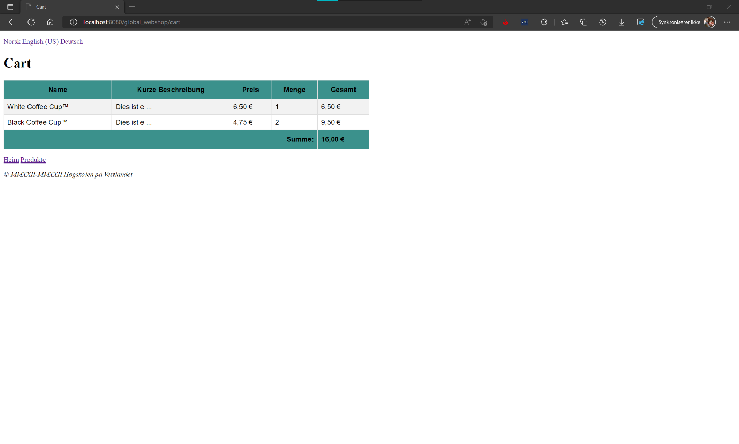

Figure 5 Global webshop demo cart (ger)